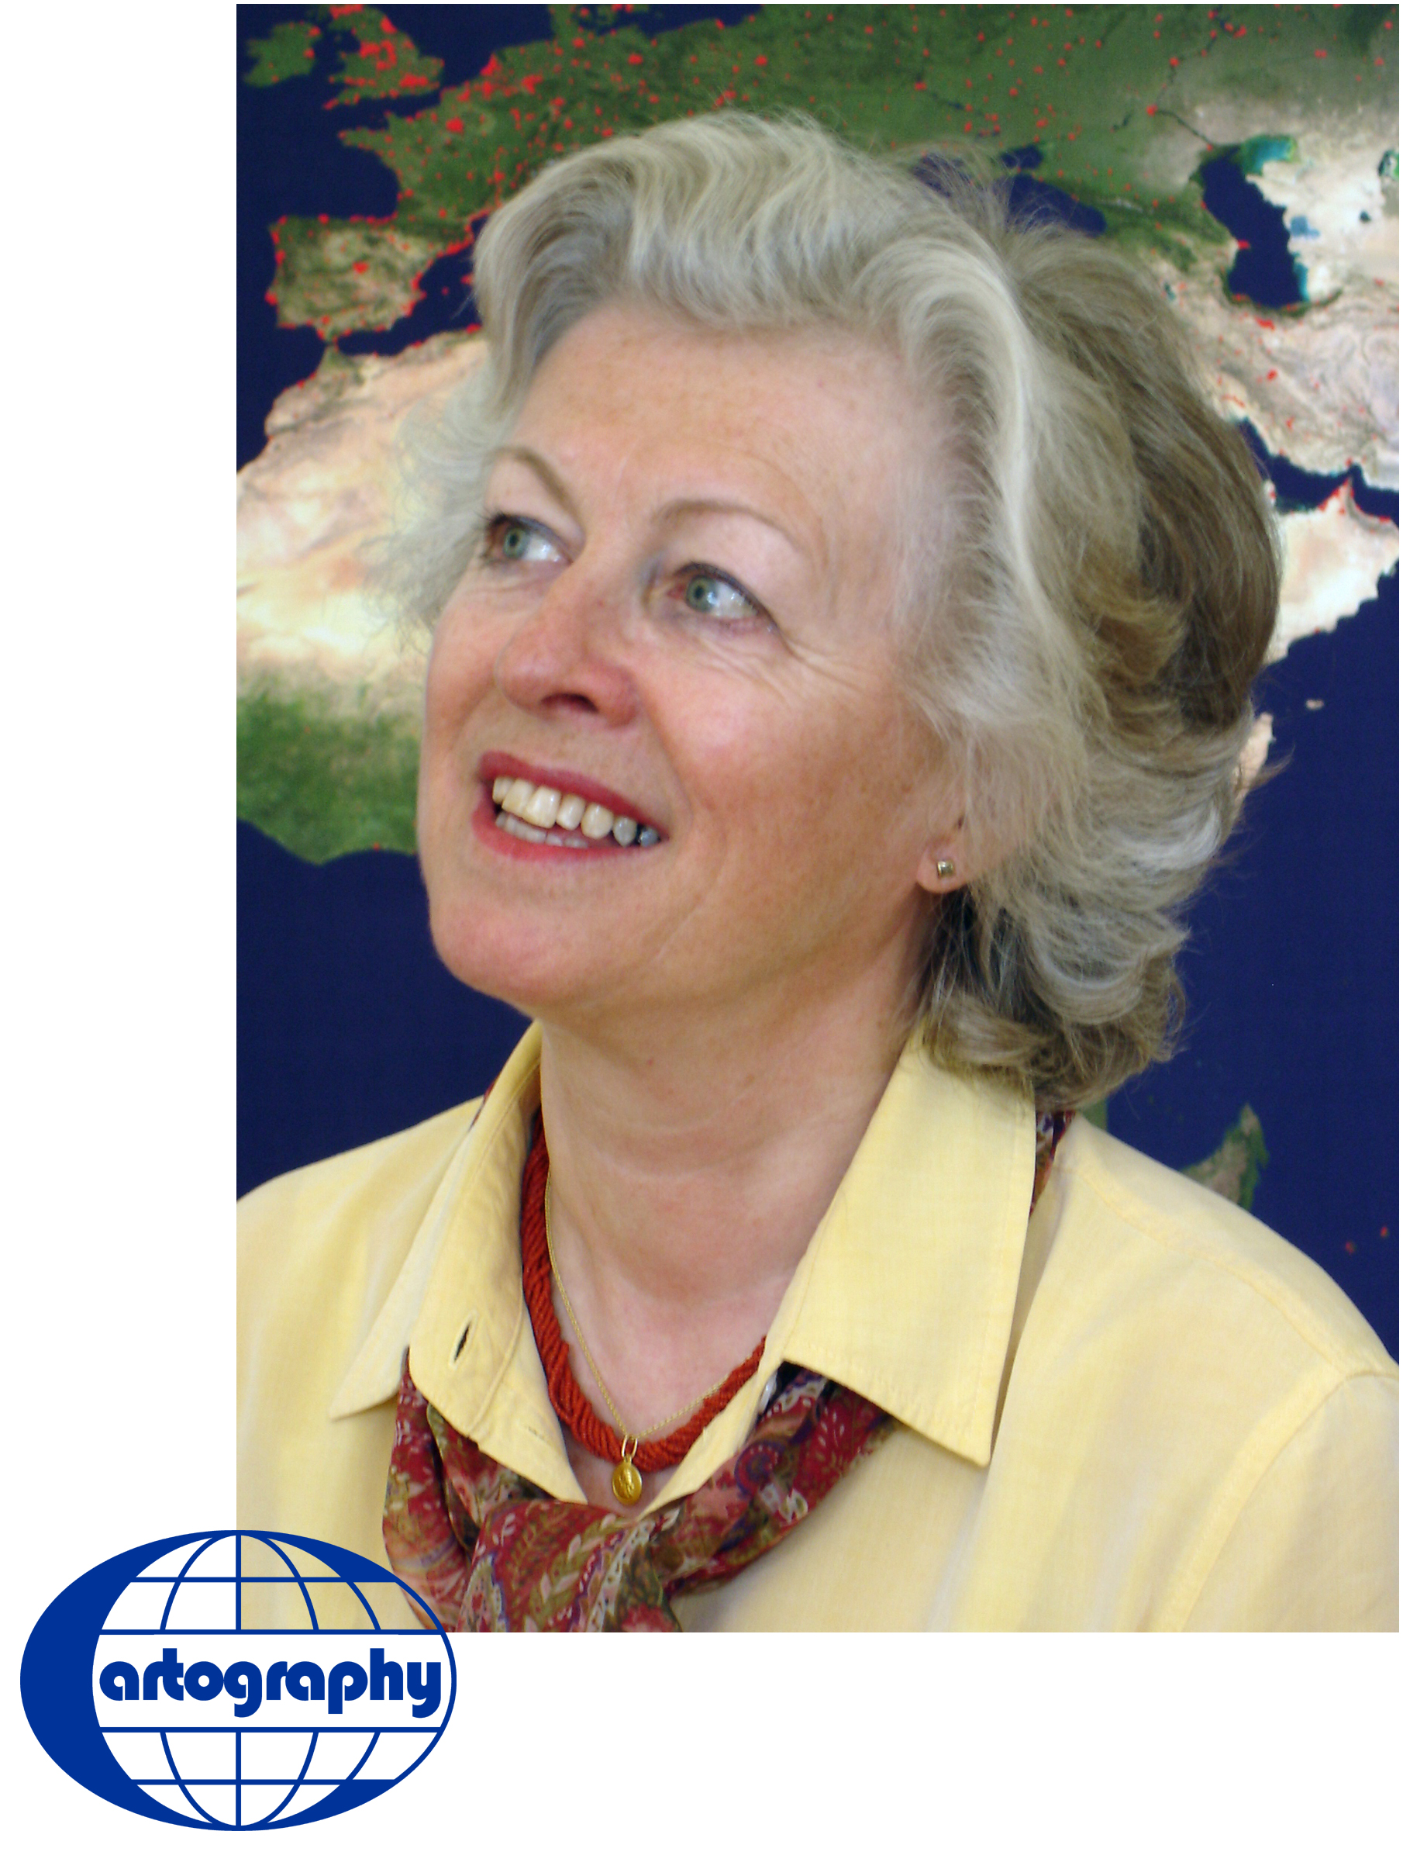
Mirjanka Lechthaler has been Assistant Professor of Cartography at the Institute for Geoinformation and Cartography at the Technical University of Vienna since 1990 where she teaches basic and advanced courses in analogue, digital and web cartography.
Dr. Lechthaler was born in Zagreb, Croatia. In 1972 she finished her studies of Geodesy with Dipl.Ing. Degree, then in 1975 her post graduate studies of Informatics at University of Zagreb. She received her Ph.D. in 1985 at the same university. Between 1972 and 1985 Dr. Lechthaler was Univ. Assistant of cartography at the Institute for Cartography and Reproduction-Techniques at the Faculty of Geodesy, University of Zagreb.

Her research interests and fields of publication are topographic and thematic modelling, quality of cartographic data, interactive and multimedia cartographic information systems and cross media publishing.

She is a Member of the German Cartographic Association, Austrian Geographic Association, Austrian Cartographic Commission, Croatian Geodetic Association and Croatian Cartographic Commission.

Finally, she is also the contact person for questions concerning “Working Committee on Equal Opportunities” at the Technical University of Vienna.
Tel: (+43 1) 58801-12610
Fax: (+43 1) 58801-12699
e-mail: lechthaler@.tuwien.ac.at

Hybrid system design for cross-media publishing in the national atlas information system
Assistant Professor DSc. Mirjanka Lechthaler

Vienna University of Technology
Cartography and Geo-Media Techniques
Department of Geoinformation and Cartography
Erzherzog-Johann-Platz 1, 1040 Wien, Austria

Phone: +43-1-58801-12610
Fax: +43-1-58801-12699
E-Mail: lechthaler@tuwien.ac.at

Abstract

This paper discusses research results at the Vienna University of Technology developed during the realisation of the prototype of Austrian national online atlas information system NAIS – ÖROK Atlas Online. It will focus on technical restrictions of the screen as an output medium and the principles of scale-adapted cartographic data preparation in a system which is relying on cartographically improved map graphics suitable for both screen visualisation and high quality printing. By establishing connections between the two media, a method for the production of adequate paper maps in a high graphical quality directly from screen visualisation was developed.

introduction
“ÖROK Atlas Online” - Atlas Information System Austria (AIS Austria) – was a cooperative research and development project for the construction of an interactive and multi-media thematic atlas of The Austrian Conference on Spatial Planning (ÖROK).
One of ÖROK’s principal tasks is to publish the “Austrian Spatial Development Concept” which is revised generally every ten years. Based on the last concept of 2001, embedded in projects there are ongoing studies and research on spatial development policy in Austria which are issued in a special publication series. One of them is ÖROK Atlas (Fig. 1).
The ÖROK Atlas Online is a web online system which enables the user – laymen and experts – to explore national and international (European) basic geo-data. Users have the possibility for searching, comparing, analysing and visualising the data. The system allows the cartographical visualisation of geometry and statistical data from the elementary geo-data pool in different map scales and in a high quality. Graphics, statistics and texts were accessible as well as queries of the data base over the interactive map based graphical user interface as a communication portal.
Further in this paper, research results at the Vienna University of Technology developed during the realisation of the prototype ÖROK Atlas Online will be applied by defining in general the characteristic of an interactive and online National Atlas Information System (NAIS).
Therefore, the once passive user of a map becomes an active manager in geographic information acquisition and visualisation (Fig. 2). The role of cartographers as designers of NAIS has also changed. They become responsible not only for transport of cartographic legible screen information via Internet, but also for all applied technological functions which allow the user to communicate online with the system involved in so called cartographic communication process (Lechthaler 2004).
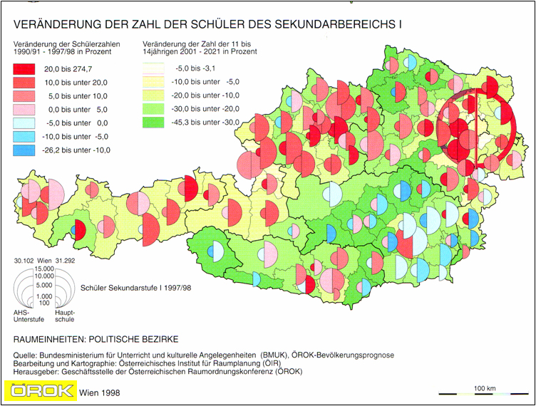
Figure 1: Thematic map from the analogue ÖROK Atlas.

By designing NAIS, the system designers also take responsibility for restrictions in terms of what is not accessible or useful. So the user cannot get any model by his interaction with the system. This would soon lead to useless and illegible visualisations of topographic as well as thematic data. It is important to limit the range of possible interactions to reasonable functionalities. This has been done without making the user feel restricted. Therefore this form of navigation and system logic is called "restrictive-flexible" (Gartner et al. 2005, Lechthaler et al. 2006) and has to been considered by the editorship.
The map graphics pose as an essential part of the graphical user interface that enables the user to investigate the provided geo-data. It will focus on technical restrictions of the screen as an output medium and the principles of scale-adapted cartographic data preparation.
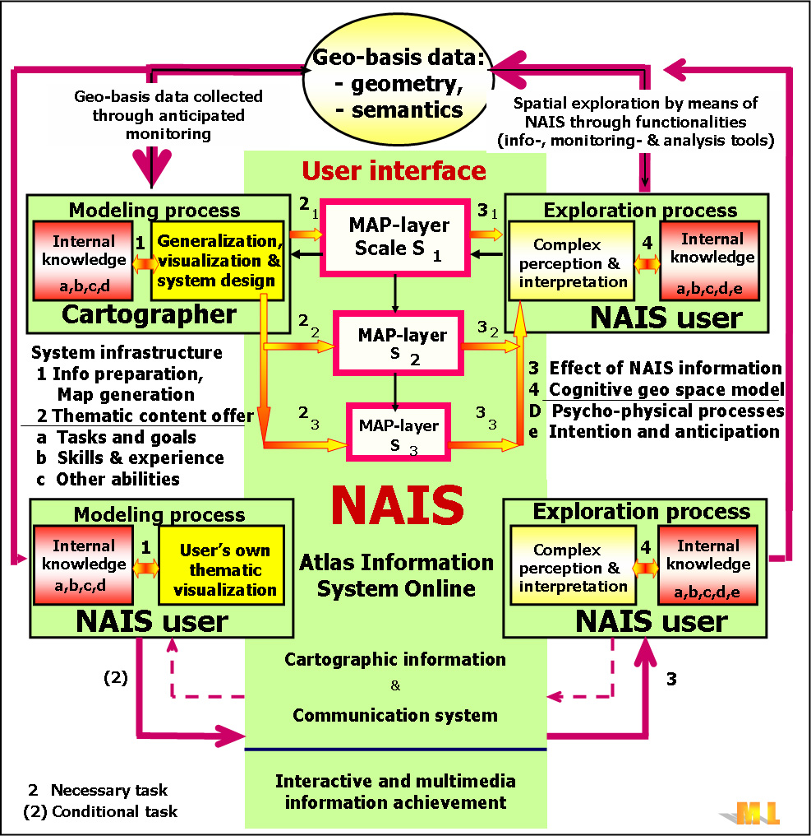

Figure 2: The complex cartographic communication process in an NAIS.

Therefore, the cartographic design issues play an important role in NAIS. They are essential for successful perception of graphical environments, reading and decoding of map information with the goal of meaningful and effective geo-communication.
Using legible map graphics in NAIS which are adapted to the technical requirements of the output medium is one of the main criteria for user acceptance. Today, the NAIS has to present a hybrid system which allows a cross-media publishing. A hybrid system is relying on cartographically improved map graphics suitable for both screen visualisation and high quality printing. Map graphics for the screen and printing medium differ in visualisation depending on the output medium resolution.
By establishing connections between the two media, a method for the production of adequate paper maps in a high graphical quality directly from screen visualisation as an integral part of the system will be shown.

the repute OF atlas information system
An atlas map work is defined as an intentional combination of maps. It is used to locate basic geo-data, i.e. space referenced objects and phenomena. Therefore, it is very important that visualised objectives reproduce geo-spatial patterns related to the physical, temporal or socio-economic human environment.
In accordance to formal and relevant features, the cartographers make distinctions among the atlases with regard to:
- output medium and presentation form (paper, haptic, electronic and multi-media atlas),
- thematic contents (complex thematic atlas, special atlases),
- format and content size (giant-, hand-, book- and pocket atlas),
- user oriented (atlases fulfilling individual and group-specific demands and with general
educational value) and
- representation area (world-, countries-, regional-, town-, space-, moon atlas).
Beside the traditional classifications of atlases, nowadays they are classified more specifically. Considering the level of interactivity and the analytic potential digital atlases could be classified in (Elzakker (1993), Kraak et al. (1996) and Ramos et al. (2005)):
- view-only atlases (print-only atlases or digital static maps without interactivity or dynamics),
- atlases with generated maps on demand (interaction with data set, changes of colour schemas, classification methods or number of classes) and
- analytical atlases based on GIS capabilities (queries to the databank through map as a graphical interface, in addition to provided map possibilities to create, analyse and visualise new data sets).
The changes towards the user as designer and author of NAIS as well as of web created geo- and cartographic information is increasingly prevalent in the information and communication community. The wireless Internet access through divided networks makes the status of geo-information domain “always on”. Therefore, this opens a quite new horizon in the way we present the geo-space. Anybody can access and provide geo-information. This results also in formation of world wide tool, knowledge and experience communities with the aim of creating a cyber, community atlas, whose author is the user self (Pulsifer et al. 2007).

Concept of hybrid system design of NAIS
A national atlas is the cartographical calling card of a country (Hurni 2004.) Unlike the topographical maps of the country national atlases convey in addition thematic information based on a consistent succession of map scales.
In the process of cross media publishing hybrid system design allows the cartographical visualisation of geometry and statistical data from the elementary geo-data pool for different output media in a high quality. The NAIS maps were primarily adapted to the technical requirements of the output medium screen. But today, the user acceptance increases, when the hybrid NAIS allows also high quality print outputs.
Due to this focus, cartography has to fulfil the obligation to achieve both – the creation of cartographic presentation forms for the new media and the acceptance of responsibility for understanding the deep relationships within the whole cartographic communication process, which includes the user, the models and the data transmission (Fig 2).

The meaning of NAIS
A number of electronic national atlases has been produced within the last twenty years (Ramos et al. 2006). Due to the new potential of the global net, national atlases become more and more important in society. Ormeling (2001) defines the concepts for multimedia national atlases and points at the new meaning of the web atlas map as an interactive interface, through which one can reach the current elementary geo-data portal (sub-national, national, trans-national and global data bases). Naturally, there are many still unanswered questions, especially regarding global as well as national policy (Hampe et al. 2004, Hardin 2006).
As an example of national multimedia atlases, the following atlases have to be mentioned here (no claim to be an exhaustive list): National Atlas of Canada [1], National Atlas of the Federal Republic of Germany, Atlas of Switzerland [2], National Atlas of the United States [3], National Atlas of Sweden [4], Online atlas of the Netherlands, Statistical Atlas of European Union (Ramos et al. 2006) as well as a few prototypes like GeoInfo Austria (Kelnhofer 2000) (Fig. 3) and ÖROK Atlas Online [5].

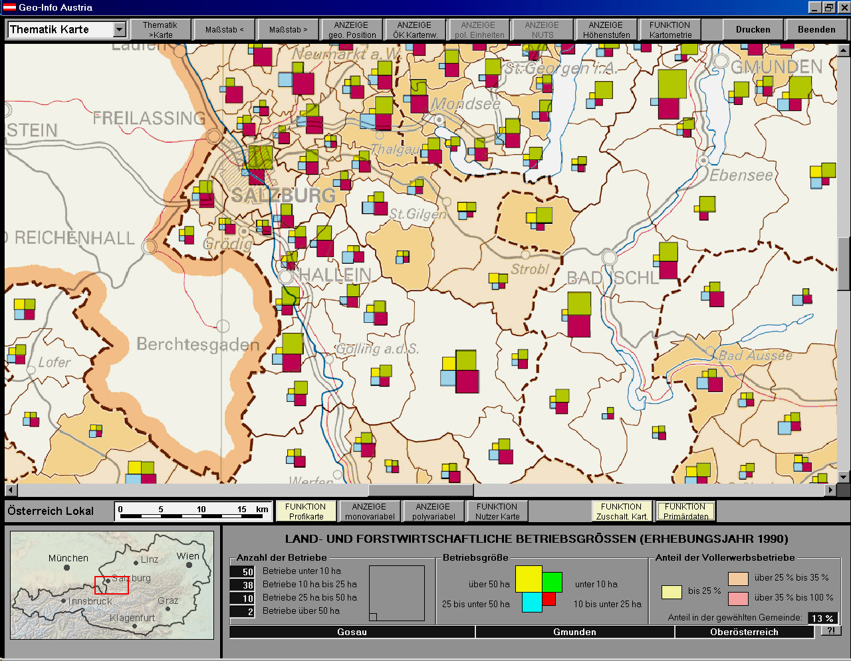

Figure 3: Thematic map from NAIS prototype GeoInfo Austria (Kelnhofer 2000).

Interactive atlas map as a user graphical interface
The communication of geo-information, facilitated through NAIS, is generally based on the use of maps as a user graphical interface, which not only restricts the visual recognition patterns, but the presentation of the earth’s surface too. The information exploration via map based interfaces is not static, but dynamic and depends on applied interactive tools.

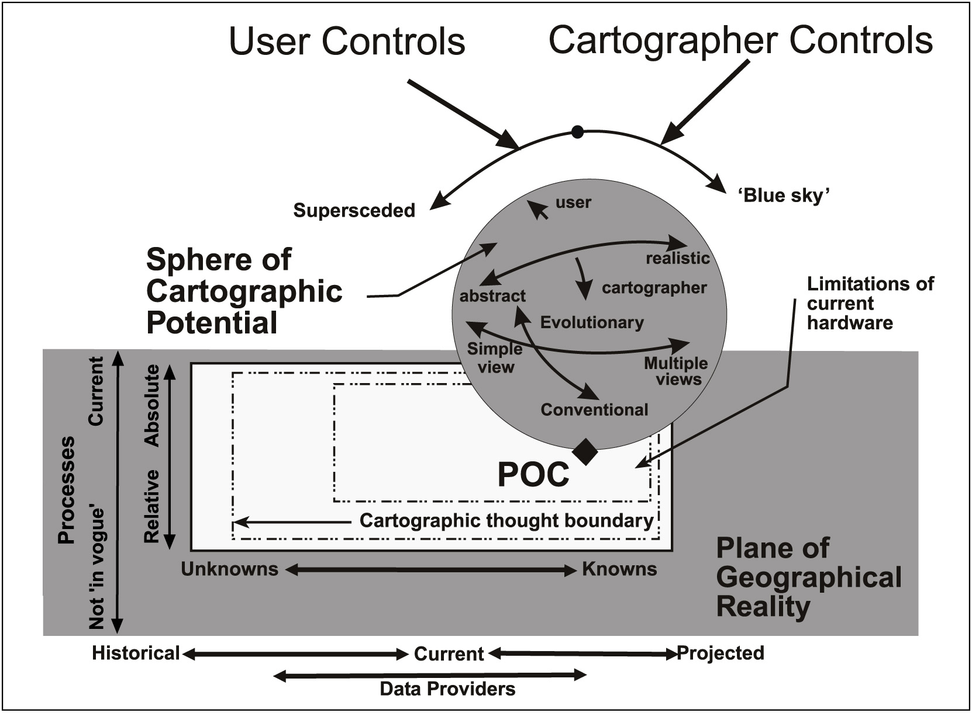
Figure 4: Sphere of cartographic potential and the plane of geographical reality (Cartwright et al. 1999; Content changed with permission of the author).

The tools and even the interactive system functionalities (Fig. 4) closely linked to general web browser functionality allowed the user to make queries to the database and to select the data variable to be visualised. Often the users need their own result displayed with own map symbology (Lechthaler 2004, Persson et al. 2005). So, the new web technology and lower equipment costs have allowed everyone, even those without cartographic knowledge, to communicate and visualise the geo-information by producing their own cartographic products.
More than ever, there is the need to apply rigorous cartographic principles, good design techniques and skills with the aim of making the communication of spatial information with NAIS richer and more efficient. Users – laymen and experts – define, depending on their aims and their experience, their own form of geo-communication based on cartographic visualised geo-space individualised (Gartner 2005), personalised (Meng 2002) and egocentrically (Meng 2004).

Role of cartographic design in a hybrid NAIS
The cartographic concept of the NAIS shows some essential considerations and decisions that are fixed in the start phase of editing such a map work. It will focus on technical restrictions of the screen as an output medium and the principles of scale-adapted cartographic data preparation in a hybrid NAIS. Using legible map graphics which are adapted to the technical requirements of the output medium (Neudeck 2001) is one of the main criteria for user acceptance. By establishing connections between the two publishing media – screen and paper – a method for the production of adequate paper maps in a high graphical quality directly from screen visualisation was developed.
The visualisation of NAIS maps according to the characteristic sheet results in deformations of the map face caused by the technical restrictions of the screen. Due to these restrictions, screen presentations suffer from deformation of the graphic elements that limit the legibility of the map (Lechthaler et al. 2006). That is why the adaptation of these map graphics is imperative.
In this respect minimal dimensions play a crucial role. Their definition is highly connected with the resolution achieved on the screen. When producing a digital map, the device-independent pixels (of which graphics are internally composed) have to be converted into those output pixels one can see on the screen. The number of output pixels defines the resolution of the screen. It is the most important restriction of this output medium. Other restrictions are the form of output pixels, the colour depth, image interferences and the refresh rate.
The average pixel size lies between 0,2mm x 0,2mm and 0,4mm x 0,4mm and the average printing resolution is about 0,1mm. According to this the screen resolution is about 2-4 times lower than the resolution of the printed map.

Minimum dimensions
When changing the scale of a map to a smaller scale, the representation of objects diminishes until it is not legible any more. Therefore the size of the objects which are yet legible is of great interest (Stadler 2004).
Minimum dimensions are minimum values for the perception (or legibility) of graphic elements (respectively map elements) concerning their size and distance from each other under normal conditions of perception (Bollmann et al. 2002, Spiess et al. 2002). They depend on two factors:
- the aligning power or resolution of the human eye – 30 cm reading distance (paper) bring aligning power of 0.05mm; 60 cm reading distance (screen) bring aligning power of 0.1mm and
- the restrictions of the used output medium and/or the efficiency of the used map production techniques.
Concerning the definition of minimum dimensions, it is important to remain above these values. The technical limitations for printing cause a minimum line width of 0.1 mm. Presuming an average reading distance of 30 cm, the value is twice as high as the aligning power for this distance and therefore suitable as a minimum dimension. Due to the coarse resolution, the minimum dimensions for screen representations clearly have to be higher – depending on the average pixel size. This deliberation was applied by creating the graphical roles for cross media publishing (Tab. 1).

 | Minimum dimensions for paper |  | Minimum dimensions for screen
Line width | 0.1 mm |  | 1 pt | 0.4 mm
Line distance | 0.2 mm |  | 2 pt | 0.8 mm
filled square | 0.3 mm |  | 3 pt | 1.1 mm
filled disc | 0.4 mm |  | 4 pt | 1.5 mm
filled rectangle | 0.3 mm x 0.6 mm |  | 3 pt x 6 pt | 1.1 mm x 2.3 mm
horizontal font | 5 pt = 1.9 mm | writing | 10 pt | 3.8 mm | Verdana
curved font | 7 pt = 2.6 mm | writing | 14 pt | 5.3 mm | Verdana

Table 1: Restriction of map design in cross media publishing.

Those recommendations are specifically focussed on thematic maps, but they also are valid for topographic data. In the following, the author will concentrate on the representation of topographic data in a NAIS.

cross media publishing within A HYBRID Nais
When thinking about a definition for map graphics, the dual character of the system has to be regarded. The system should provide visualisations suitable for the screen as well as high quality printouts. These two output media differ in terms of technical and formal restrictions. To stay legible, adapted map graphics have to be used in both cases.
Automated generalisation is yet not possible. Therefore, each map-geometry (topography) can not be derived on-the-fly in individual scales (Edwardes et al. 2003, Brunner-Friedrich at al. 2007). Consequently, it is necessary for a NAIS to define, visualise and harmonise geometry data in series of fixed scales, which has to be cartographically processed in advance. Each of those scales represents the real world in another spatial resolution. The visualisation of thematic data in NAIS bases on selected topographic objects, which are scale and screen adapted.
In consideration of the basic rules of screen adapted geo-visualisation, Lechthaler et al. (2006) developed a recommendation for the characteristic sheets for the succession of scales: 1:250k (the basic scale of NAIS), then 1:500k and 1:1mio. Deformations of the map graphic by screen restriction should be kept to a minimum, which is why only limited zoom areas within a scale level should be allowed. The screen adapted map graphics should guarantee a high quality presentation of the cartographic objects and phenomena on screen.
Besides the presentation on screen, modern users also expect an analogue output. When designing a map for the presentation on screen, significantly higher minimum dimensions than for printed maps have to be considered because of the lower screen resolution. Presuming a relatively large pixel size of 0,375 mm (1 pt) and an average printing resolution of 0,1 mm, the resolution of the medium screen is about 4 times lower than that of printed maps. This implies that a screen-adapted map can be used for printing in a scale that is 4 times smaller but has the same information content. For instance, the 1:250k screen map was used to generate a 1:1mio. print map (Fig. 5). Since there are no reasons, why a screen adapted map could not be used for printing in a scale 4 times smaller than the original screen map.
As mentioned before, only lettering had to be treated separately!

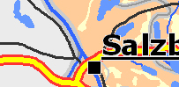
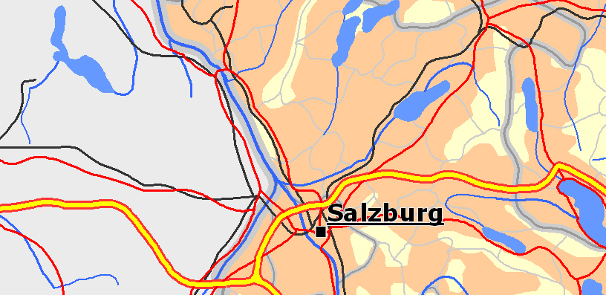
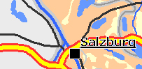
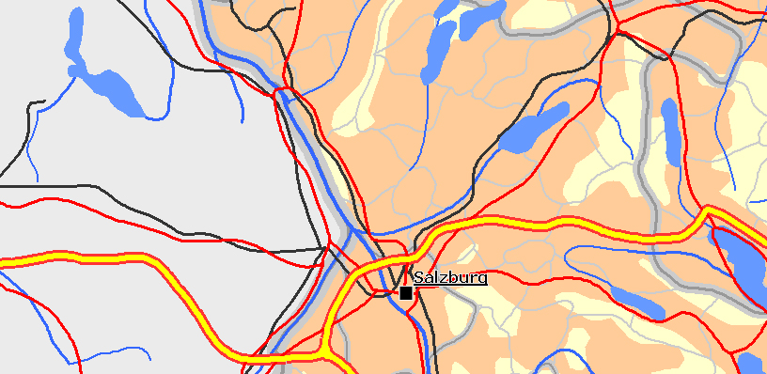
d
c
b
a

Figure 5: Extract of the screen adapted geo-visualisation of topographic elements a) 1:250k, b) 1:1mio and the corresponding printouts c) 1:1mio, d) 1:4mio.

CONCLUSIONS
The core task of this work was to establish connections between screen and paper as different types of output media for cartographic applications in the Austrian national online atlas information system – ÖROK Atlas Online. The resolution of a screen is approximately 4 times lower than the resolution of printed maps, so the minimum dimensions as well as applied map symbolisation had to be defined 4 times larger. This is why the application of screen adapted map graphics takes up more map space. This has an effect on the information content of the atlas map. By the implementation of interaction tools, the lower graphic density is compensated by the ability to fully investigate the system and all the primary data behind it.
Since there are no reasons, why a screen adapted map could not be used for printing in a scale 4 times smaller than the original screen map. Both outputs have the same information content, which correspond to the content, users are accustomed to get in print maps.
Taking into account these principles both output media – screen and paper – may provide satisfying information on the geo-space in its entirety and graphically visualised in a high quality.

References
Bollmann, J. & W. G. Koch (2002): Lexikon der Kartographie und Geomatik. Heidelberg, Spektrum.
Brunner-friedrich, B. & M.Lechthaler: Konzept zur Automatisierung der Prüfung kartographischer Sachdatenumsetzung im Hinblick auf ihre Lesbarkeit. In: In: Strobl, J., G. Griesebner (Hrsg.): Angewandte Geoinformatik 2007, Beiträge zum 19. AGIT - Symposium, Salzburg. CD Ausgabe.
Cartwright, W. & M,-P. Peterson (1999): Multimedia Cartography. In: Cartwright, W. M.P. Peterson and G. Gartner (Eds.): Multimedia Cartography. Berlin: Springer. 1-11.
Edwardes, A., D. Burghardt, M. Bobzien, L. Harrie, L. Lehto, T. Reichenbacher, M. Sester & R. Weibel (2003): Cartographic Renaissance, Proceedings of the 21st International Cartographic Conference (ICC) Durban, South Africa. 171-180.
Elzakker C. V. (1993): The use of electronic atlases. In: Klinghammer, I., L. Zentai & F. Ormeling (Eds.): Seminar on Electronic Atlases. Cartographic Institute of Eötvös Lorand University, Visegrad, Hungary. 145-155.
Gartner, G. (2005):Individualisierung in der Kartographie am Beispiel der Siedlungsselektion. KN, 4, 181-187.
Hake, G., Grünreich, D. & Meng, L. (2002): Kartographie. 8. Aufl. Berlin, De Gruyter.
Hampe, M., S. Afflerbach, & A. Illert, (2004): Harmonisierung und Integration europäischer Datenbestände - Implementierung und Nutzen. In: Dodt, J. & S. Schulz (Eds.): Kartographische Schriften, "Der X Faktor - Mehrwert für Geodaten und Karten". Königslutter am Elm. Bonn, Kirschbaumverlag. 9, 39-45.
Hardin, D. (2006): Using Data from Earth Orbiting satellites in Geo-Hypermedia Application: A Survey of Data Resources. In: Stefanakis, E., M.-P. Peterson, C. Armenacis & V. Delis (Eds.): Geographic Hypermedia, Concepts and systems. Berlin, Springer. 53-71.
Hurni, L. (2004): Vom analogen zum interaktiven Schulatlas: Geschichte, Konzepte, Umsetzungen. In: Kainz, W., K. Kriz, A. Riedl (Eds): Aspekte der Kartographie im Wandel der Zeit. Institut für Geographie und Regionalforschung der Universität Wien. S. 222-233.
Kelnhofer, F. (2000): Das duale Prinzip in der Atlaskartographie. Ergebnisse des FWF - Teilprojektes „Geoinformationssysteme und EDV-Kartographie“. In: Mitteilungen der Österreichischen Geographischen Gesellschaft. Österreichische Geographische Gesellschaft, Wien, pp. 39-68.
Kraak, M.-J. (2001): Web Maps and Atlases. In: Kraak, M.-J. & A. Brown (Eds.): Web Cartography, Taylor and Francis, London. 135-140.
Kraak, J.-M. & F. Ormeling (1996): Cartography: visualisation of geospatial data. Longman Scientific & Technical, Essex.
Lechthaler, M. (2004): Cartographic Models as a Basis for Geo-Communication. In: Kereković, D. (Ed.): Geographical Information Systems in Research&Practice. International Conference on GIS. GIS Forum - Hrvatski Informatički Zbor, Zagreb, Croatia. 19-32.
Lechthaler, M., Ch. Spanring & G. Kazlberger (2005): Cartographic Concept of Atlas Information System „ÖROK Atlas Online“ – AIS Austria. In: Lapaine, M. Eds.): Kartografija i Greoinformacije. Journal of the Croatian Cartography Society. 4, 30-45.
Lechthaler, M., Ch. Spanring & G. Katzlberger (2006):Cartographic Information System „ÖROK Atlas Online“ – AIS Austria as a Communication Portal of Austrian Basic Geo-Data. In: Medak, D. (Ed.): Geodetski list. Zagreb, Croatian Geodetic Society. 4, 241-259.
Lechthaler, M: & A. Stadler (2006): Output Media Adapted Cartographic Visualisation. In: Banissi, E:, A. Burkhard, A. Ursyn, …(Eds.): Information Visualisation, Proceedings. London, IEEE. 304-309.
Meng, L. (2002): Personalisierung der Kartenherstellung und Mobilität der Kartennutzung. In: Kartographische Schriften, "Kartographie als Baustein moderner Kommunikation“. Königslutter am Elm. Bonn, Kirschbaumverlag. 9, 10-16.
Meng, L. (2004): Methoden zur Gestaltung egozentrischer Karten. In: Dodt, J. & S. Schulz (Eds.): Kartographische Schriften, "Der X Faktor - Mehrwert für Geodaten und Karten". Königslutter am Elm. Bonn, Kirschbaumverlag. 9, 113-122.
Neudeck S.(2001): Zur Gestaltung topografischer Karten für die Bildschirmvisualisierung. Dissertation, Universität der Bundeswehr München, Heft 74.
Ormeling, F. (2001): Das Bändigen von Multimedia-Konzepten für den Online-Atlas der Niederlande. In: Herrmann, Ch. & H. Asche (Eds.): Web.Mapping 1 – Raumbezogene Information und Kommunikation im Internet, Wichmann, Heidelberg. 178 – 189.
Persson, D., G. Gartner & M. Buchroithner (2005): Towards Typology of Interactivity Functions for Visual Map Exploration. In: Stefanakis, E., M.-P. Peterson, C. Armenacis & V. Delis (Eds.): Geo-Hypermedia’05, Proceedings of the 1. International Workshop on Geographic Hypermedia, Denver, Colorado, U.S.A.
Peterson, M.-P. (2005): Hypermedia Maps and the Internet. In: Stefanakis, E., M.-P. Peterson, C. Armenacis & V. Delis (Eds.): Geo-Hypermedia’05, Proceedings of the 1. International Workshop on Geographic Hypermedia, Denver, Colorado, U.S.A.
Pulsifer, P.-L., S. Caquard & D.-R.-F. Taylor (2007): Toward a New Generation of Community Atlases – The Cybercartographic Atlas of Antarctica. In: Cartwright, W., M.P. Peterson &. G. Gartner (Eds.): Multimedia Cartography. Springer, Berlin. 195-216.
Ramos, C.-DA S., & W. Cartwright (2005): Atlases from paper to digital medium. In: Stefanakis, E., M.-P. Peterson, C. Armenacis & V. Delis (Eds.): Geo-Hypermedia’05, Proceedings of the 1. International Workshop on Geographic Hypermedia, Denver, Colorado, U.S.A.
Ramos, C.-DA S., & W. Cartwright (2006): Atlases from paper to digital medium. In: Stefanaikis, E., M.-P. Peterson, C. Armenacis & V. Delis (Eds.): Geographic Hypermedia, Concepts and systems. Berlin, Springer. 97-119.
Siekierska, E. & D. Williams (1996): National Atlas of Canada on the Internet and School-Net. In: Köbben, B., F. Ormeling & T. Trainor (Eds.): Seminar on Electronic Atlases II, ICA Commission on National and Regional Atlases, Prague. 19-23
Spiess, E., U. Baumgartner, S. ARN & C. Vez (2002): Topographische Karten, Kartengraphik und Generalisierung. Schweizerische Gesellschaft für Kartographie (Eds.). Kartographische Publikationsreihe Nr.16.
Stadler, A. (2004): Verknüpfung korrespondierender Kartenelemente im Hinblick auf automatisierte Fortführung. Diploma thesis, Department of Geoinformation and Cartography, Vienna University of Technology.
Taylor, D.-R.-F. (2003): The Concept of Cybercartography. In: Peterson, M. (Ed.): Maps and the Internet. Cambridge, Elsevier.
Werner, M: & E. Hutzler (2006): Contemporary Map Design with Desktop-Publishing System Extensions. In: Kriz, K., W. Cartwright, A. Pucher & M. Kirnberger (Eds.): Kartographie als Kommunikationsmedium. Wiener Schriften zur Geographie und Kartographie. 17, 224-232.

URLS – last visited on 2007-01-24.
[1] http://atlas.nrcan.gc.ca/site/index.html Atlas of Canada
[2] http://www.atlasderschweiz.ch/english/3d/index.html Atlas of Switzerland
[3] http://nationalatlas.gov/natlas/Natlasstart.asp National Atlas of the United States
[4] http://www.sna.se/webbatlas National Atlas of Sweden
[5] http://www.oerok-atlas.at/ ÖROK Atlas Online

